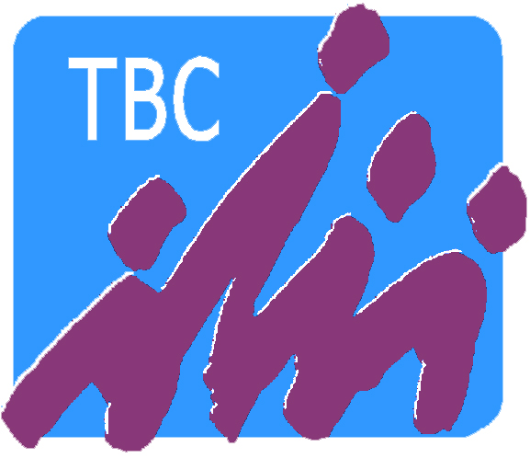
Teen Bible Challenge, Inc. Parent Consent Form
2013-2014 Season

As parent/guardian of the following child(ren),

_____________________________________ ________________________________________
Name of child Name of child

_____________________________________ _______________________________________
Name of child Name of child

_____________________________________ _______________________________________
Name of child Name of child

I hereby grant permission to Teen Bible Challenge, Inc. to use photographs and/or videos of my child(ren) for promotional purposes only, and to post information about my child(ren) on the Teen Bible Challenge website, as indicated below:

Please check appropriate box:

YES NO
[ ] [ ] May we use photographs or videos of your child(ren) for promotional
purposes?
[ ] [ ] May we use photographs or videos of your child(ren) on our website
or social media?
[ ] [ ] May we post your child(ren)'s name on the website or social media
as a quizzer? *
* Quizzer names and any contact information will not be available to the general public through our website but will only be accessible to participants of TBC or KBC and its staff who are registered users of the website.

_____________________________________________________ ________________________
Signature of Parent/Guardian Date

